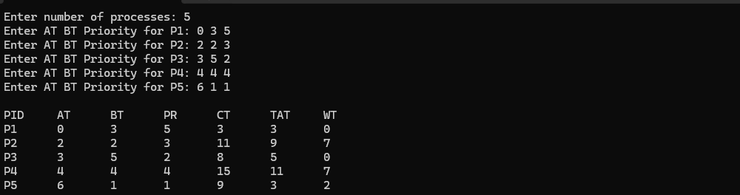

#include <stdio.h>
#include <stdbool.h>

int main() {
int n;

printf("Enter number of processes: ");
scanf("%d", &n);

int pid[n], at[n], bt[n], pr[n];
int ct[n], tat[n], wt[n];
bool completed[n];

for(int i = 0; i < n; i++) {
pid[i] = i + 1;
completed[i] = false;

printf("Enter AT BT Priority for P%d: ", pid[i]);
scanf("%d %d %d", &at[i], &bt[i], &pr[i]);
}

int current_time = 0;
int completed_count = 0;

while(completed_count < n) {
int highest_priority = 9999;
int selected = -1;

for(int i = 0; i < n; i++) {
if(at[i] <= current_time && !completed[i]) {
if(pr[i] < highest_priority) {
highest_priority = pr[i];
selected = i;
}
}
}

if(selected == -1) {
current_time++;
} else {
int start_time = current_time;

ct[selected] = start_time + bt[selected];
tat[selected] = ct[selected] - at[selected];
wt[selected] = tat[selected] - bt[selected];

current_time = ct[selected];
completed[selected] = true;
completed_count++;
}
}

printf("\nPID\tAT\tBT\tPR\tCT\tTAT\tWT\n");

for(int i = 0; i < n; i++) {
printf("P%d\t%d\t%d\t%d\t%d\t%d\t%d\n",
pid[i], at[i], bt[i], pr[i], ct[i], tat[i], wt[i]);
}

return 0;
}

